**Purpose:**

The purpose of this standard operating procedure is to walk you, the user, through the joint measurement analysis (JMA) toolbox.

**Scope:**

**Notes:**

**Programs Used:**

SPM Toolbox from <http://www.spm1d.org/install/InstallationMatlab.html>

MATLAB from <https://www.mathworks.com/>

Parallel Computing Toolbox for MATLAB

**Pre-requisites:**

**Procedures:**

1. **Statistical Parametric Mapping (SPM) Toolbox**
   1. Download the spm1D package (<https://spm1d.org/>), extract wherever you need, and then add the package to the MATLAB path. This will allow the spm1D package to be called from any function or script without needing to be in the same file path.

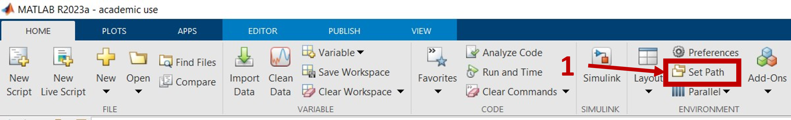

*MATLAB > Home > Set Path (1)*

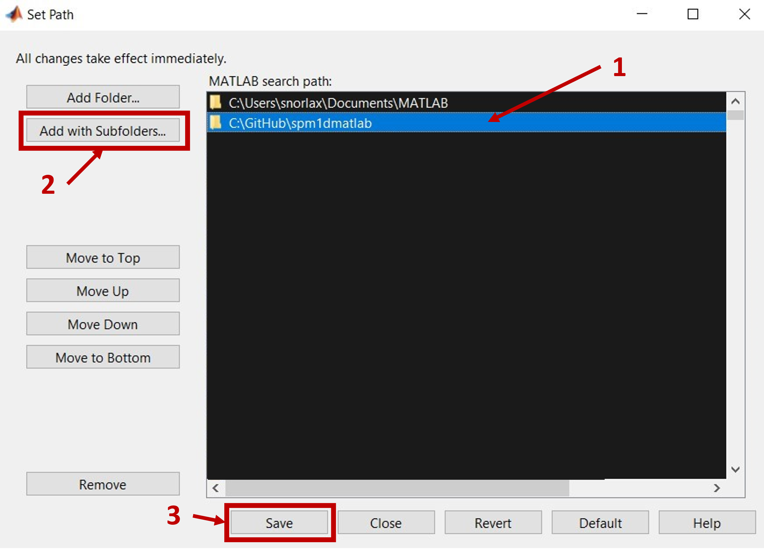

*Select the folder location (1) > Add with Subfolders… (2) > Save (3)*

1. **Creation of participant-specific files:**

In order to run the JMA you will need to have several specific files for each participant placed in nested folder. The idea is that these folders are created in the directory with the JMA scripts and so it should be easy point and click to run.

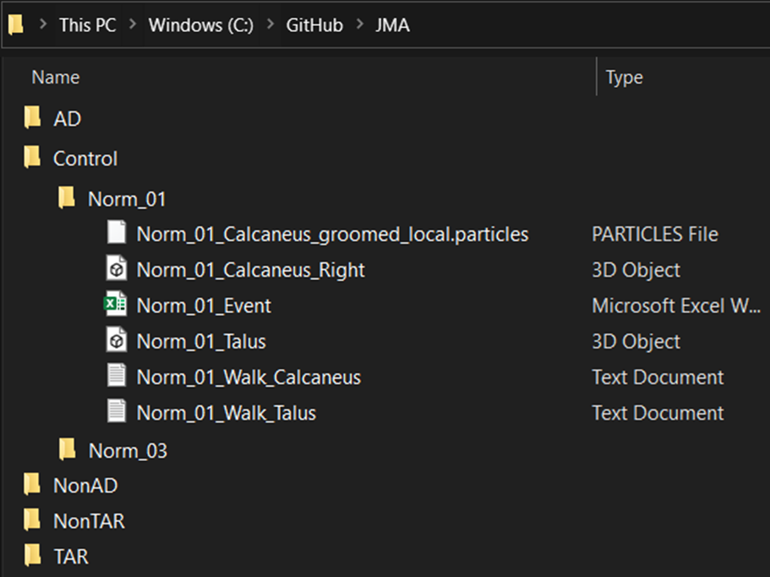

* 1. **Kinematic files** (.txt)
     1. **Purpose:** The kinematic files contain bone-specific 4x4 transformation matrices for each frame (or time point) of a tracked activity. The purpose of this is for transforming the bone models to their tracked location for each frame. ***This file is not necessary for single time point static JMA.*** If the .txt file is not within the participant-specific folder the script will assume a static single time point and will automatically proceed using an identity matrix.
     2. **Naming Convention:** In order for this script to load the data properly it just needs to have the name of the bone within its filename. The spelling needs to be consistent and specific as one of the user inputs of the JMA_01 script is the names of the bones.
     3. **Format:** Within the file each row is a single frame or time point and there are 16 columns. Every four values are a row of the 4x4 matrix. For example, when constructing an identity matrix in this format it will look like this: [**1,0,0,0,0,1,0,0,0,0,1,0,0,0,0,1]** with each color denoting a different row.
  2. **Event files** (.xlsx or .csv)
     1. **Purpose:** The event file is for truncation and normalization of the data to percentage of the activity. From the test dataset it is from heel-strike to toe-off. ***This file is not necessary for single time point static JMA or if you do not have events that you would like to normalize to.*** If you would like to normalize to the tracked activity and have provided a kinematic file that is longer than one time point, then by not including this file it will normalize to the length of the kinematic file (i.e., the length of the activity).
     2. **Naming Convention:** In order for this script to load the data properly it just needs to have the name of the bone within its filename. The spelling needs to be consistent and specific as one of the user inputs of the JMA_01 script is the names of the bones.
     3. **Format:** Within the file it will have a single row and 4 columns. It will be truncated to common percentages of the normalized activity from the first tracked frame to the last tracked frame. The frame selected for heel-strike frame will be 0% and the frame selected for toe-off frame will be 100% of the normalized activity. From the test dataset the excel sheet will have [**first tracked frame, heel-strike frame, toe-off frame, last tracked frame**].
  3. **Bone files** (.stl)
     1. **Purpose:** The bone models are the surfaces that the distances and curvatures will be calculated from. These bone models should be smoothed, decimated, and the mesh resolution constructed to your needs. It is recommended that you mesh with edge lengths that result in a high-resolution mesh, as a sparse mesh will lead to erroneous measurement calculations. For example, the test dataset each bone was meshed with a maximum edge length of 0.5 mm and then smoothed to eliminate rough triangle edges. The coordinate space of these bone models should be those that match the kinematic transformation matrices.
     2. **Naming Convention:** Each of the bone .stl files will need to have the name of the bone in the filename. The spelling needs to be consistent and specific as one of the user inputs of the JMA_01 script is the names of the bones. So, if there any variations or inconsistencies from what you input into JMA_01 you will have issues and the files will not properly load. For any specific joint analysis at least one of the .stl bone files of that joint will need to have the laterality of those bones included in the name. This can be done by including “_right_”, “_left_”, “_R_”, or “_L_” (upper or lower case it doesn’t matter) somewhere within the file name. For example, if you were running JMA on the subtalar joint, as in the test dataset, you will need to include the laterality in either the talus or the calcaneus .stl filenames, *ParticipantID*_Talus_left.stl. If no laterality is included in either of the .stl filenames it will be assumed that they are a right sided limb. The laterality is needed as the kinematic files are likely not reflected to match the reflection of the bones needed for a good correspondence model within ShapeWorks (right is the assumed convention here).
  4. **Correspondence Particle files** (local.particles)
     1. **Purpose:** The correspondence particle files for each participant are outputs from ShapeWorks and can be found within its project file. The world.particles particle locations are on the surface of the models from the groom steps. The local.particles particle locations are on the surface of the models when they are imported into ShapeWorks. This toolbox uses the local.particles and aligns the bone model to their respective correspondence particles using an iterative closest point algorithm in order to pair bone model surface nodes to the correspondence particles.
     2. **Naming Convention:** In order for this script to load the data properly it just needs to have the name of the bone within its filename. The spelling needs to be consistent and specific as one of the user inputs of the JMA_01 script is the names of the bones.

1. **Creation of group files (Mean_Models folder):**
   1. **Bone files** (.stl)
      1. **Purpose:** The mean shape of a study group is used for creating figures showing the joint space results. See the figure below for example of how to locate where to export the mean shape for a specific group. From this same place you can also export the correspondence particles for that study group mean shape. (See below figure for example)

*ShapeWorks > Analyze > Group Set (1) > Group (2) > Mean (3) > File > Export > Current Mesh*

* + 1. **Naming Convention:** In order for this script to load data properly it just needs to have the name of the bone and the study group within its filename separated by underscores (e.g., *Mean_StudyGroup_BoneName.*stl).
  1. **Correspondence Particles** (.particles)
     1. **Purpose:** The mean shape of a study group is used for creating figures showing the joint space results. See the figure below for example of how to locate where to export the mean shape for a specific group. From this same place you can also export the correspondence particles for that study group mean shape.

*ShapeWorks > Analyze > Group Set (1) > Group (2) > Mean (3) > File > Export > Current Particles*

* + 1. **Naming Convention:** In order for this script to load data properly it just needs to have the name of the bone and the study group within its filename separated by underscores (e.g., *Mean_StudyGroup_BoneName.*particles).

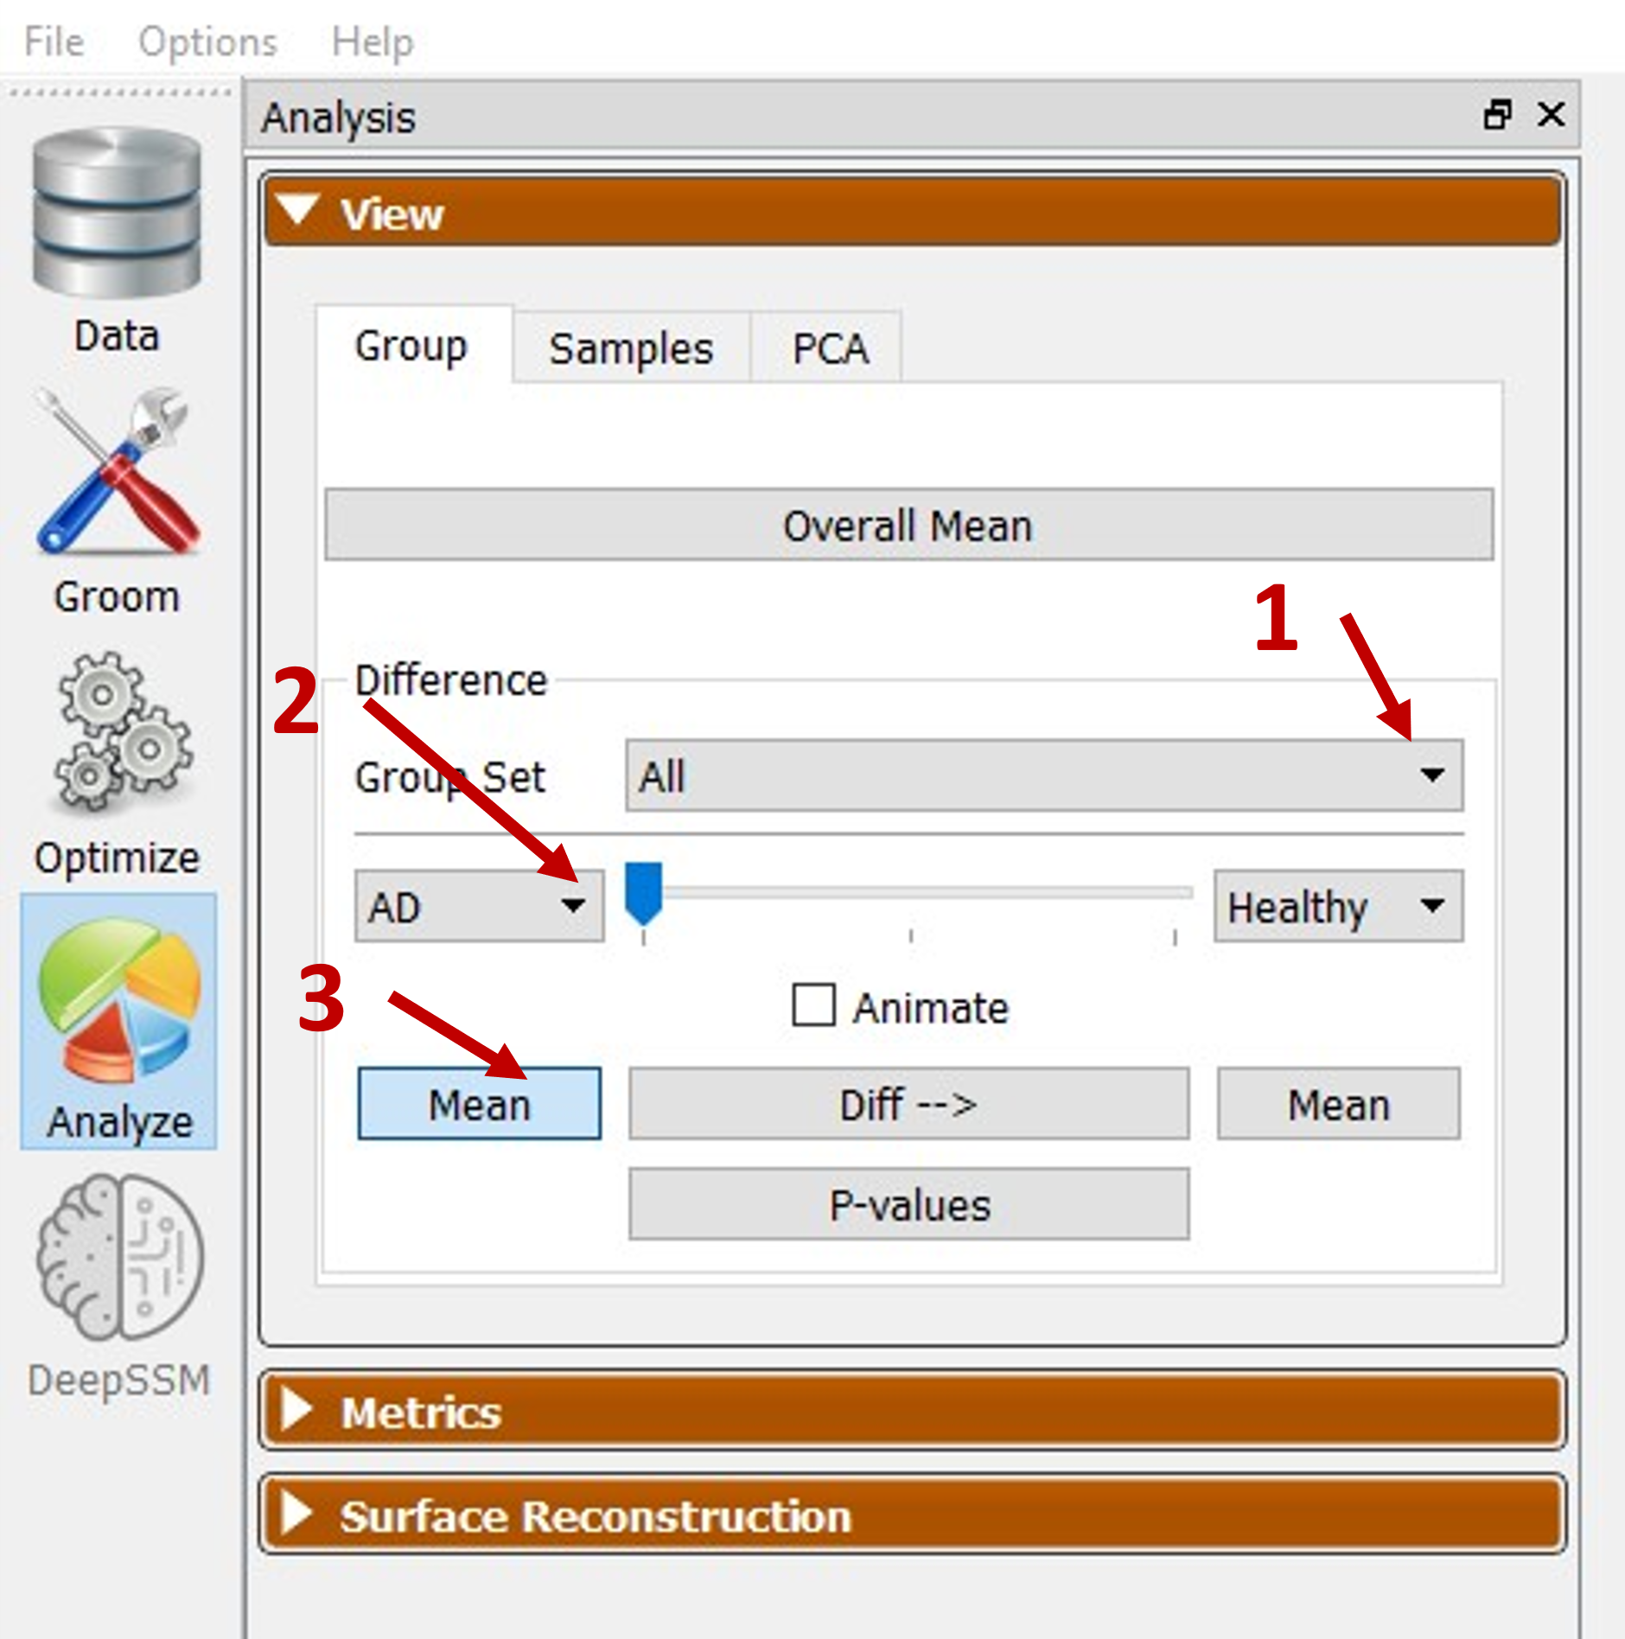

1. **Consolidate data for each participant:**
   1. The JMA Toolbox operates out of the Current Folder directory and therefore you will need to copy/move files into folders within the JMA directory to be able to proceed. A test case dataset has been included within the toolbox GitHub repository as an example. Please see below section **Test Case Data** for more information on the included dataset.
   2. The JMA Toolbox utilizes study group folders with nested participant-specific folders to load and save data (see below figure). Each study group will have its own folder (e.g., Controls, Pathologic, etc.) and nested within each of those folders will be that study group’s participant-specific folders containing the necessary files. The name of the study group folder (AD, Control, NonAD, etc.) and the name of the participant-specific folders dictates the names of the data structures used in the MATLAB script. A few things to note, the names should not start with numbers as this will cause the scripts to crash (cannot be structure names starting with numbers), cannot include hyphens or dashes (‘-‘), and the participant-specific folders do not need to match the study group folder name. The scripts will check each folder directory for specific file types and query the filename for identifying naming conventions (listed above in section 2) which includes the bone name and laterality.



* 1. **Importing your own data:**

If you are wanting to import your own data to be compared at the correspondence particle locations you just need to add an .xlsx or .csv file of the participant-specific data into their respective folders. The structure of this spreadsheet is as follows: each row contains the data for each frame and the data for each node needs to be located at the column indices that match the bone model node indices. For example, see the figure below. If there is no data for a node at a time point leave the cell blank or empty. The structure names and the file names will have be in lower case and will be named the data file name without the participant-specific identifier. **So it is important to have the names other than the identifiers be consistent!** For example, if you are running it with FEA results a control participant could be called Control_01 and the FEA data spreadsheet named Control_01_FEA.csv and the outputs for the FEA results will have ‘fea’ in their name rather than ‘Distance’ or ‘Congruence’.

1. **Test Case Dataset:** The test case data provided includes three individuals surgically treated with tibiotalar arthrodesis and their untreated contralateral limb (AD_02, AD_04, and AD_10), two individuals surgically treated with total ankle replacement and their untreated contralateral limb (TAR_04 and TAR_06), and two healthy asymptomatic controls (Norm_01 and Norm_03). The data for each of these participants is in participant-specific folder within their respectivegroups.
2. **Processing Data:**
   1. **JMA_01_Kinematics_to_SSM.m**
      1. **Disclaimer:** This script will take the longest to run and is the most computationally expensive portion of the DJMA process. Depending on your computer you will have varying computational times. The machine used for processing the data for the manuscript had an AMD Ryzen 9 5950X 16-Core Processor and 64 GB of DDR4-32000 RAM. With 16 workers it took on average 180 seconds per frame (excluding the first frame) to calculate the joint space measurement data. Future work may implement further developments for optimizations and reduce computational time.
      2. **Running the Script:** After arranging the files into the appropriate folder structures you are ready to start processing some data. The script will save the data every 50 frames in case it gets interrupted. There is a tic toc function to measure the elapsed time for each frame processed. This is to help give an idea how long it will take to process the data for a participant.

* Open and run the MATLAB script JMA_01_Kinematics_to_SSM.m. You will be prompted with a popup asking you to enter user inputs.
* Enter name of bone that data will be mapped to – this is the name of which bone correspondence particles you would like to map the data to.
* Enter name of opposite bone – this is the name of the opposing bone that distances from the previous bone will be calculated to.
* Enter number of study groups – this is how many groups you want to process; you can process them separately or in tandem.
* Would you like to overwrite previous data? – If set to 1 it will save over previous .mat files for that specific joint. If the overwrite previous data is set to 1 it will start from the first frame and ignore previous .mat files. If it is set to 0 it will load any previous .mat files for that joint and continue where it was last saved.
* How often would you like to save the .mat file in case of interruptions? – Every x number of frames it will save the structures to a .mat file.

* 1. **JMA_02_Data_Process_and_Normalize.m**
     1. The JMA_02_Data_Process_and_Normalize.m script will normalize and truncate the data to consistent percentages of stance for the data measured from the JMA_01_Kinematics_to_SSM.m script. When you run it, you will be asked to enter the names of the bones and enter number of study groups then prompted to select the folders just as you did with JMA_01. It is important to note that it will only normalize across those that are selected. I suggest selecting all your groups, or all 5 in the example data set, so they are consistent, and it will be easier to make comparisons in the stats JMA_03 scripts.
     2. The results from this script will be stored in a structure and saved as a .mat file with a name starting in ‘Normalized_Data’ within the …\MAT_Files\JMA_02_Outputs\ folder. The beginning of the file name will be concatenated with the names of the groups processed (e.g., ‘Normalized_Data_Calcaneus_Talus_AD_Control_NonAD_NonTAR_TAR.mat’).

* 1. **JMA_03_SPM_Analysis.m**
     1. The JMA_03_SPM_Analysis.m script will calculate the temporal statistically significant clusters using the t-test spm1D toolbox of the joint space measurement results at each correspondence particle throughout the activity. **This code will not work for static single time point comparisons.**
     2. **Running the script: User Inputs**
* Enter distance upper limit – sets the upper limit and any group mean joint space distance measurements above this will be removed from the analysis. This will also remove it from the congruence index comparison as well.
* Enter distance lower limit – sets the lower limit. There should not be anything lower than 0 unless you are having overlap of the bones in which case something went wrong and you should investigate your transformation matrices or the .stl files for the bones to ensure that they are in the right coordinate space.
* View Perspective(1) – Sets the first angle for the view perspective for the figures. You will be given the option to view and rotate the model to set the viewing perspective later if needed.
* View Perspective(2) – Sets the second angle for the view perspective for the figures.
* Select viewing perspective? – If set to 1 (yes) then it will create a figure and a menu prompt. Rotate the figure to the view that you want and then select “Done” on the menu. It will update the viewing perspective for the figures and will display those values in the command window so you can use those for future figures. The camera light will update in the figures so do not worry about the lighting.

* + 1. **Running the script: Selecting and loading .mat file**

Select the .mat file with the normalized data to be processed. It will have the title Normalized_Data_*BoneName1_BoneName2_StudyGroup1_...StudyGroupN*.mat. The field *BoneName1* is the bone with the correspondence particles and *BoneName2* is the opposing bone. It will then list off the groups included in the .mat file. This is so that multiple variations can be run and saved from the same directory depending on your needs.

* + 1. **Running the script: Selecting first group to compare**

The first group to compare is which study group bone model will be used and that group’s mean results will be displayed on the bone model. Select the first group and select “OK”.

* + 1. **Running the script: Selecting the second group to compare**

The second group to compare is which study group the first group will be compared against. If measurements at a correspondence particle are statistically significant (p<0.05) they will be circled in pink. Select the second group and select “OK”.

* + 1. **Running the script: Select which data to analyze**

Select which data you would like to analyze, if more than one is selected (using shift or control click) you will process each of those selected.

* + 1. **Running the script: Select viewing perspective (If set to 1 in the User Inputs)**

If select viewing perspective was changed to 1 you will be prompted to rotate a figure to the desired orientation. When you select the figure to begin rotating the “Select when done” menu will become an inactive window, if you move the figure you can see it again. After selecting “Done” it will report the viewing perspective angles in the command window. This is so you can type them in later for easier use or for consistency.

*Figure > Rotate 3D (1) > Rotate the figure (2) > Done (3)*

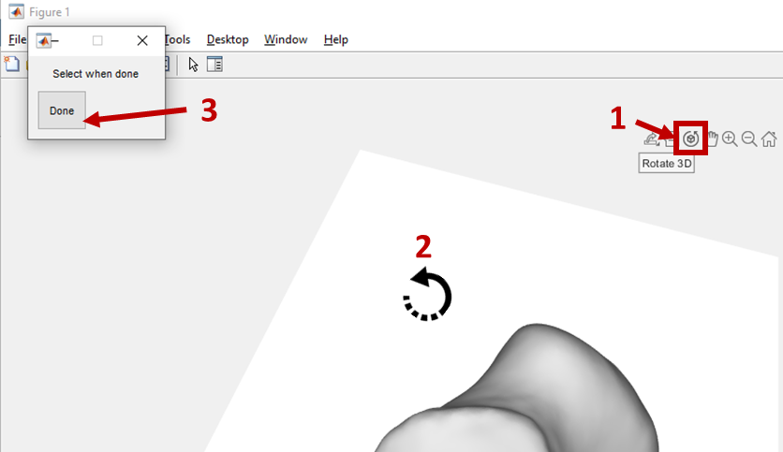

* + 1. **Running the script: Results**

For each time point of the normalized activity a .tif image will be created and saved. Once each of the time points have had an image created, they are stitched together into a .mp4 video. These .tif images are saved in the results folder and follow a specific naming convention.

…\Results\SPM_Particles_*JM*_*Bone1_Bone2*\*JM_StudyGroup1_vs_StudyGroup2*

*JM* = Joint Measurement (Dist for distance and CI for congruence index)

*Bone1* = Name of bone one, the bone that the data is mapped to

*Bone2* = Name of the opposing bone

*StudyGroup1* = The group results visualized within the figure

*StudyGroup2* = The group that the data is statistically compared against

* 1. **JMA_03_Discrete_Multigroup_Comparison.m**
     1. The JMA_03_Discrete_Multigroup_Comparison.m script will calculate the normality, t-test (if two groups), or ANOVA (if more than two groups) of the joint space measurement results at each correspondence particle. This code will work for static single time point comparisons. There are no corrections for temporal analyses, they are done at each time point independent of one another. If more than two groups are selected at the prompt discussed in 6.4.4 then an ANOVA and Kruskal-Wallis test will be performed, if only two are selected than a two-sample *t-*test and Wilcoxon rank sum test will be. For the list of tests see the below figure. In sections 6.4.5 and 6.4.6 you will be asked to select the two groups to compare out of the groups selected in 6.4.4. If the data for a specific joint measurement is found to be not normal using a Shapiro-Wilk test at each correspondence particle within a time step the nonparametric results will be used.

|  |  |  |  |
| --- | --- | --- | --- |
|  | n = 2 | n > 2 | Shapiro-Wilk Normality Test |
| Two-sample *t*-test | X | - | Parametric |
| Wilcoxon rank sum Test | X | - | Nonparametric |
| One-way ANOVA  Test | - | X | Parametric |
| Kruskal-Wallis Test | - | X | Nonparametric |

* + 1. **Running the script: User Inputs**
* Enter the name of the comparison – Adds this name to the beginning of the result figures for specific ANOVA or multigroup comparison conditions set by the user. Helps to identify these results.
* Enter distance upper limit – Sets the upper limit and any group mean joint space distance measurements above this will be removed from the analysis. This will also remove it from the congruence index comparison as well.
* Enter distance lower limit – Sets the lower limit. There should not be anything lower than 0 unless you are having overlap of the bones in which case something went wrong and you should investigate your transformation matrices or the .stl files for the bones to ensure that they are in the right coordinate space.
* View Perspective(1) – Sets the first angle for the view perspective for the figures. You will be given the option to view and rotate the model to set the viewing perspective later if needed.
* View Perspective(2) – Sets the second angle for the view perspective for the figures.
* Select viewing perspective? – If set to 1 (yes) then it will create a figure and a menu prompt. Rotate the figure to the view that you want and then select “Done” on the menu. It will update the viewing perspective for the figures and will display those values in the command window so you can use those for future figures. The camera light will update in the figures so do not worry about the lighting.
* Alpha Value – the threshold for statistical significance

* + 1. **Running the script: Selecting and loading .mat file**

Select the .mat file with the normalized data to be processed. It will have the title Normalized_Data_*BoneName1_BoneName2_StudyGroup1_...StudyGroupN*.mat. The field *BoneName1* is the bone with the correspondence particles and *BoneName2* is the opposing bone. It will then list off the groups included in the .mat file. This is so that multiple variations can be run and saved from the same directory depending on your needs.

* + 1. **Running the script: Selecting the groups**

This menu will ask you select the groups to include, if more than two groups are selected it will perform one-way ANOVA and Kruskal-Wallis tests for statistical significance.

* + 1. **Running the script: Selecting first group to compare**

The first group to compare is which study group bone model will be used and that group’s mean results will be displayed on the bone model. Select the first group and select “OK”.

* + 1. **Running the script: Selecting the second group to compare**

The second group to compare is which study group the first group will be compared against. If measurements at a correspondence particle are statistically significant (p<0.05) they will be circled in pink. Select the second group and select “OK”.

* + 1. **Running the script: Select which data to analyze**

Select which data you would like to analyze, if more than one is selected (using shift or control click) you will process each of those selected.

* + 1. **Running the script: Select viewing perspective**

Please see section 6.3.7.

* + 1. **Running the script: Results**

For each time point of the normalized activity or for the single time point a .tif image will be created and saved. Once each of the time points have had an image created, they are stitched together into a .mp4 video. These .tif images are saved in the results folder and follow a specific naming convention.

…\Results\SPM_Particles_*JM*_*Bone1_Bone2*\*JM_StudyGroup1_vs_StudyGroup2*

*JM* = Joint Measurement (Distance, Congruence, or your own data name)

*Bone1* = Name of bone one, the bone that the data is mapped to

*Bone2* = Name of the opposing bone

*StudyGroup1* = The group results visualized within the figure

*StudyGroup2* = The group that the data is statistically compared against

* 1. **JMA_04_Mean_Group_Results.m**
     1. The JMA_04_Mean_Group_Results.m script allows for creation of participant-specific or mean study group results figures without comparisons.
     2. **Running the script:**
     3. Similar set up to JMA_03 scripts, see sections 6.3.2 and 6.4.2. The only difference is that you will be asked if you want to show group or participant-specific results. If you select participants, you will be prompted with a list of the groups, select the group and then select the participant you wish to see and make .tif images and .mp4 video of. If you select group, you will just need to select which group and it will show that group’s mean data at each particle on the mean shape. No stats will be performed on the data.

1. **Interpreting Results:**
   1. **Finding the results:** All of the figures and videos created are saved in the “Results” folder. Within the Results folder there will be multiple folders created as you process and analyze data. The naming convention of these folders are as follows: 1) Analysis script output, 2) Data name, and 3) Joint.
      1. Analysis script output is the first part of the folder name

*Multicompare_Particles_*  : Data from JMA_03_Discrete_Multicompare_Comparison.m

*Results_Particles_* : Data from JMA_04_Mean_Group_Results.m

*SPM_Particles_*  : Data from JMA_03_SPM_Analysis.m

* + 1. Data name is the name of the data structure (Distance, Congruence, etc.)
    2. Lastly the joint. The joint will be named by the two bone name inputs from the User Input prompt when it was executed. The first bone name is the bone with the data mapped correspondence particles and the second bone name is the opposing bone.
  1. Each stack of .tif images are saved into their respective folder and the .mp4 video will be saved one directory up of the location of the images used to create that video.

* 1. **Data structures:** Each output .mat files are located in the “MAT_Files” folder and will have a specific folder for JMA_01 and JMA_02. The .mat files in the JMA_01 folder will contain compiled raw data from each participant. The .mat files in the JMA_02 folder will have the truncated and normalized data for each participant and group within it.
     1. **JMA_02 .mat results**

The architecture of these truncated normalized data when loaded is as follows:

|  |  |  |
| --- | --- | --- |
| Variable Name | Type | Description |
| bone_names | cell array | The names of the bones of the analyzed joint with the first being the bone with the mapped correspondence particles |
| DataOut | structure | Participant-specific mapped data at each particle across the normalized activity |
| DataOut_Mean | structure | Group mean results at each particle across the normalized activity |
| DataOut_SPM | structure | Compiled group results at each particle across the normalized activity |
| DataOutAll | structure | All of the results placed in one array, used for calculating mean and standard deviations of the data across the entire dataset |
| max_frames | double | The total number of common percentages, used for iteration in future scripts |
| per_stance | double | Common percentages of the normalized activity |
| SPM_check_list | structure | Logical cell array identifying particles at specific time points that are suitable for SPM analysis (1 = has data of each participant at that particle) |
| subj_group | structure | The study group names and the participant identifiers within each group |

|  |  |  |
| --- | --- | --- |
| **Revision Date** | **Revision Author** | **Revision Description** |
| 2023-03-23 | R. J. Lisonbee | Drafted |
|  |  |  |
|  |  |  |
|  |  |  |
|  |  |  |
|  |  |  |
|  |  |  |
|  |  |  |
|  |  |  |
|  |  |  |
|  |  |  |
|  |  |  |
|  |  |  |
|  |  |  |